Pahlavi Glossary
-stan (home/place): -stʾn'
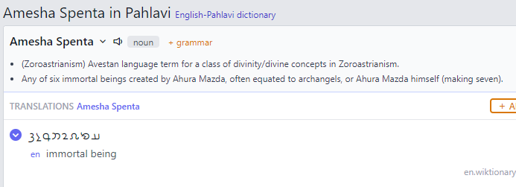
Army: gwnd
Assyria: ʾswl
Babylon: bʾbyl
Balkh: bhl
Byzantium :
H/x l/r w q/m ?

Christian:
kristiyān / tarsāg

Ctesiphon: tyspwn
Edessa: ʾlhʾy

Elephant: pyl

Fasting:
lwck'
en act or practice of abstaining from or eating very little food

Father: pid/pidar
Fire: ādur
Five:
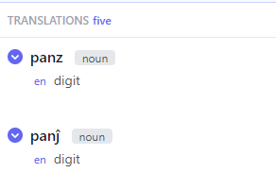
God:
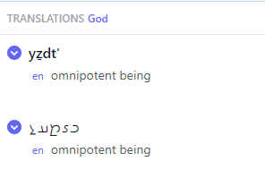
Hell:
Hrycania:
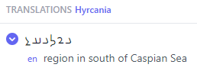
Karen: 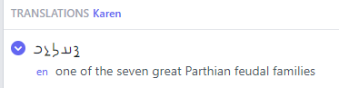
King:
Miracle: widimāsīh
Mecca: mkkh
Mesopotamia:
Mountain: kōf
Mind: mānag
Monastery: mānestān
North: abāxtar
Paradise:
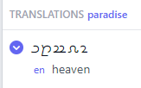

Parthia:

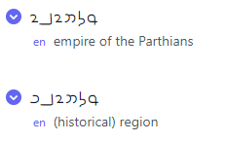
Persia:
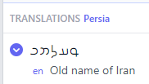

Poem: cagāmag
en literary piece written in verse

Religion:

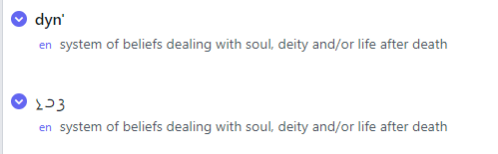
Shahanshah: 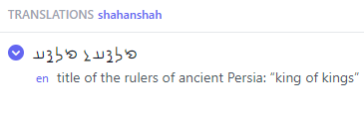

Sogdian: swkwstʾn'

Stone: Sang or sng
Tigris:

Water: 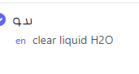

Zoroaster: 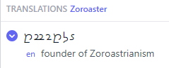

A peculiarity of the Pahlavi writing system was the custom of using Aramaic words to represent Pahlavi words; these served, so to speak, as ideograms. An example is the word for “king,” in Pahlavi shāh, which was consistently written m-l-k after the Aramaic word for “king,” malka, but read as shāh.

